(Assignment 4)

1. . Explore “iris” data as follows:

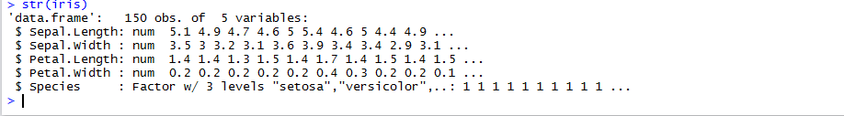

1. Plot “iris” data as shown below:

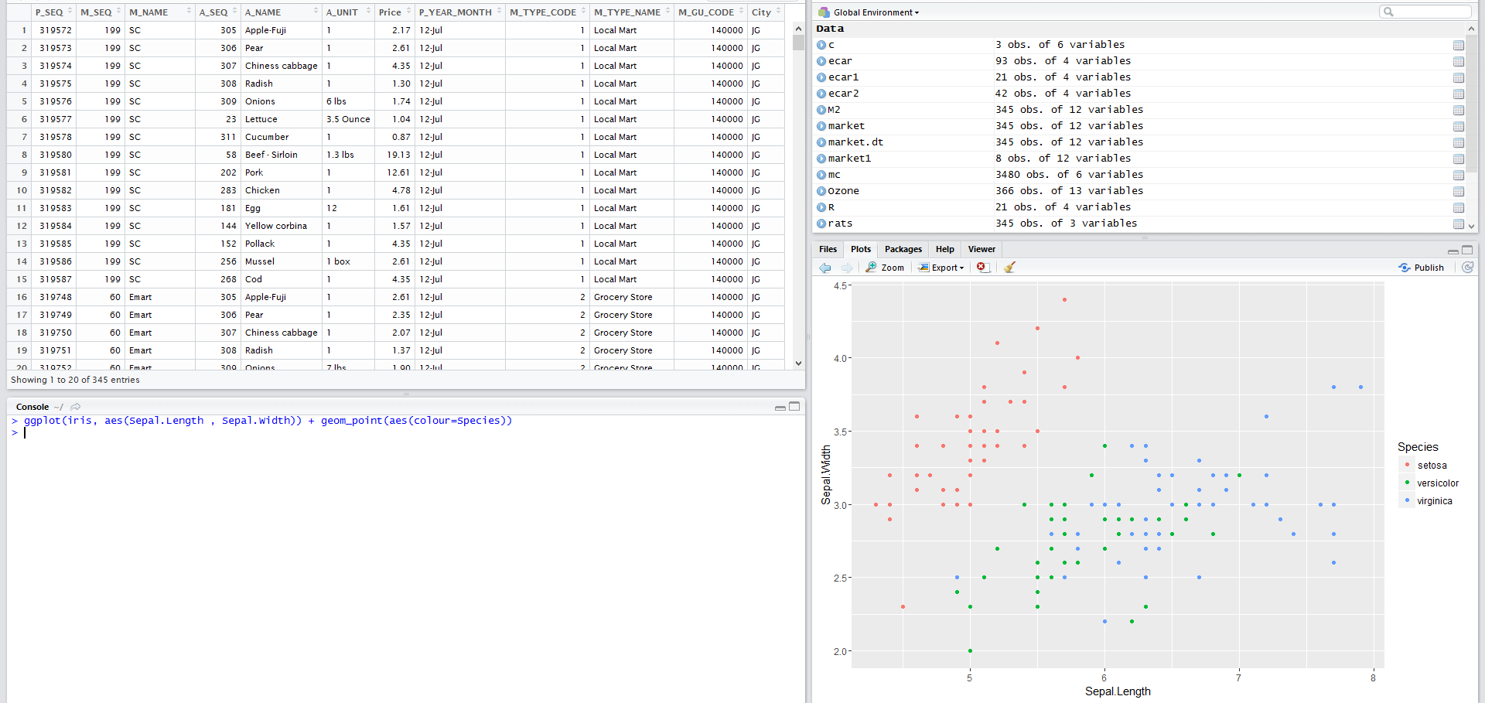

1. Resize the point of each species in the plot based on the width of Petal shown below:

